**EARLY PREDICTION FOR CHRONIC KIDNEY DISEASE DETECTION: A PROGRESSIVE APPROACH TO HEALTH MANAGEMENT**

***1.INTRODUCTION***

**OVERVIEW:**

**DESCRIPTION**

Chronic Kidney Disease (CKD) is a major medical problem and can be cured if treated in the early stages. Usually , people are not aware that medical tests we take for different purposes could contain valuable information concerning kidney diseases. Consequently, attributes of various medical tests are investigated to distinguish which attributes may contain helpful information about the disease. The information says that it helps us to measure the severity of the problem, the predicted survival of the patient after the illness, the pattern of the disease ad work for curing the disease.

In todays world as we know most of the people are facing so many disease and as this can be cured if we treat people in early stages this project can use a pretrained model to predict the Chronic kidney Disease which can help in treatments of peoples who are suffer from this disease.

CKD is a condition in which the kidneys are damaged and cannot filter blood as well as they should. Because of this, excess fluid and waste from blood remain in the body and may cause other health problems, such as heart disease and stroke.

*Project flow:*

* User interacts with the UI to enter the input.
* Entered input is analysed by the model which is integrated.
* Once model analyses the input the prediction is showcased on the UI

To accomplish this, we have to complete all the activities listed below,

* Define Problem/Problem Understanding
* Data collection & Preparation
* Exploratory Data Analysis
* Model Building
* Performance Testing & Evaluate this results
* Model Deployment
* Project Demonstration & Documentation

**PURPOSE**

Your kidneys remove wastes and extra fluid from your body. Your kidneys also remove acid that is produced by the cells of your body and maintain a healthy balance of water, salts, and minerals—such as sodium, calcium, phosphorus, and potassium—in your blood.

Without this balance, nerves, muscles, and other tissues in your body may not work normally.

Your kidneys also make hormones that help

* Control your blood pressure
* Make red blood cells
* Keep your bone strong and healthy

**ACHIVEMENT**

* The main of treatment is to prevent progression of CKD to complete kidney failure.
* The best way to do this is to diagnose CKD early and control the underlying cause.
* The symptoms, evaluation and management of CKD will be reviewed here.
* Kidney transplantation, peritoneal dialysis and hemodialysis are discussed separately.

**2.PROBLEM DEFINITION & DESIGN THINKING**

1. **Empathy Map**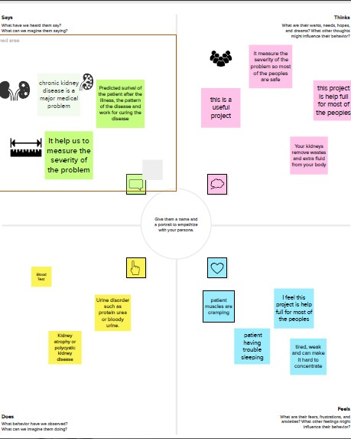
2. **Ideation & Brainstorming Map**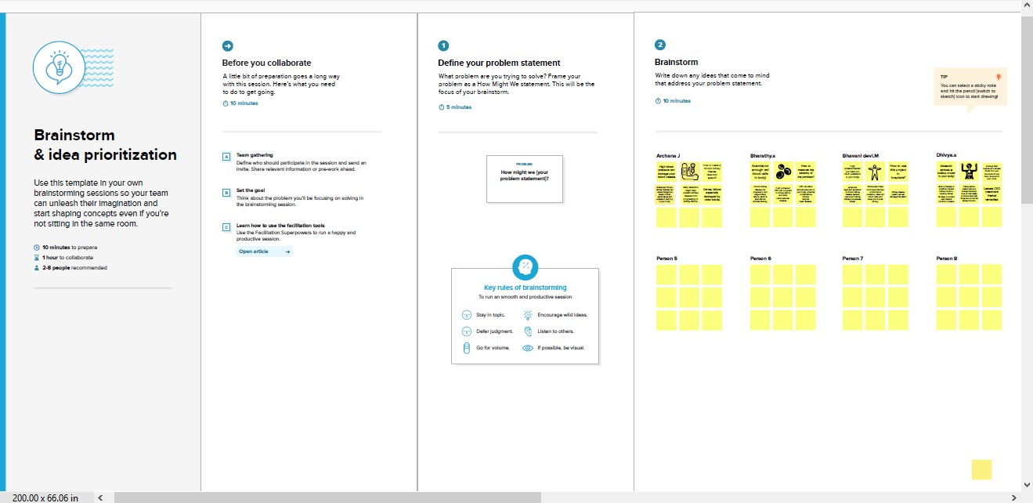

**3.RESULT:**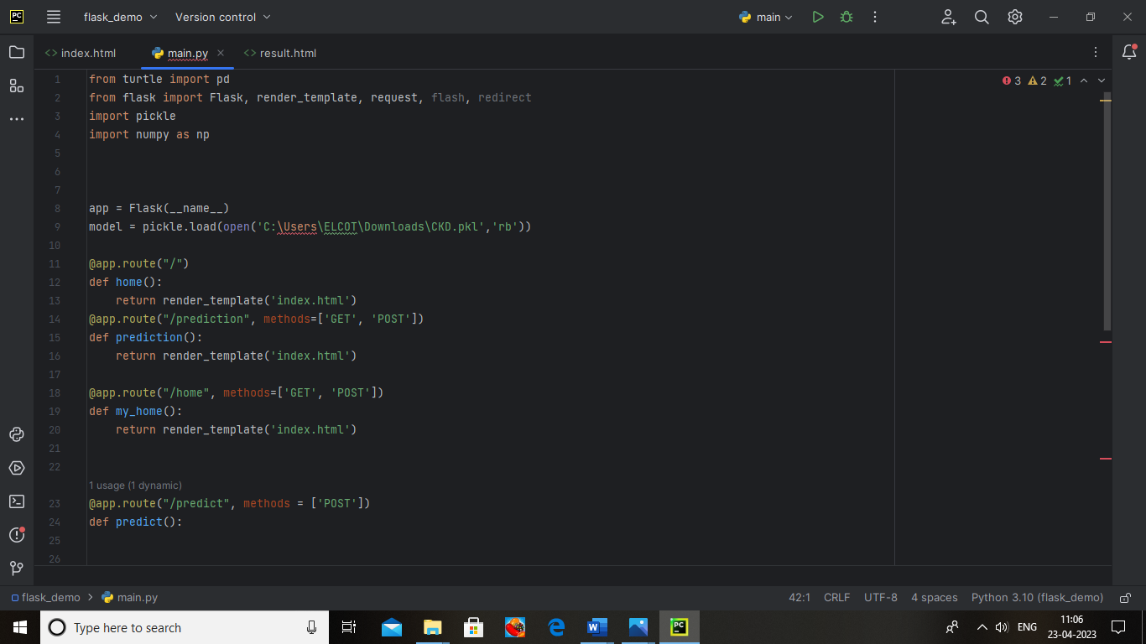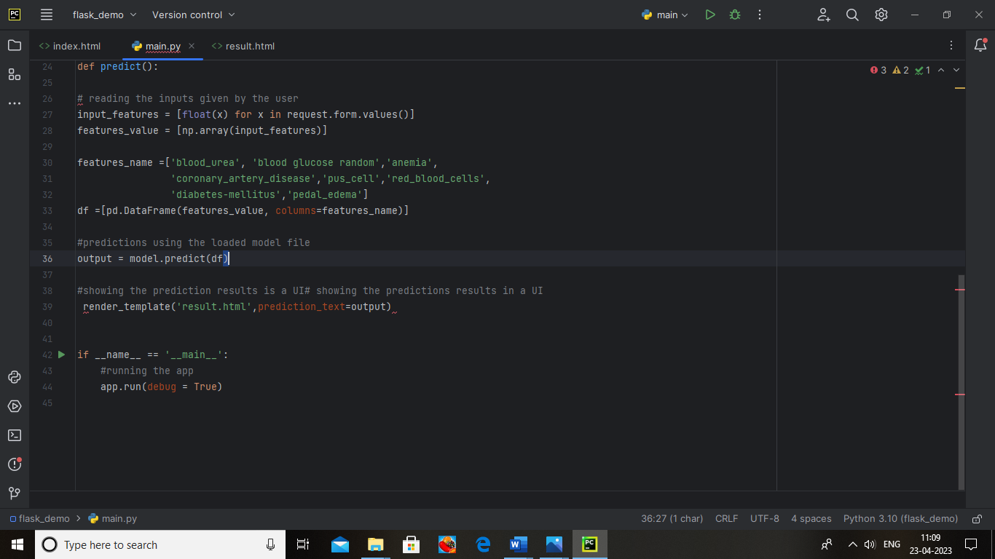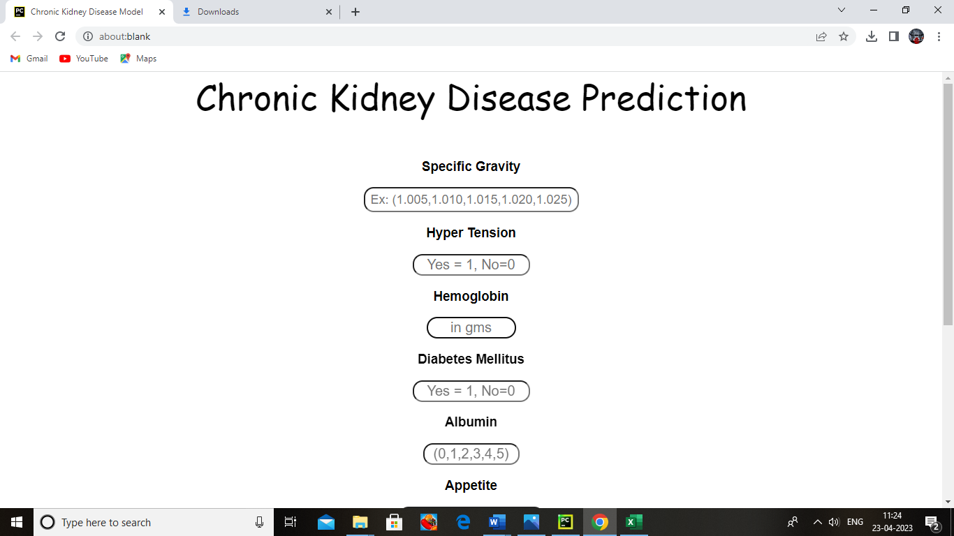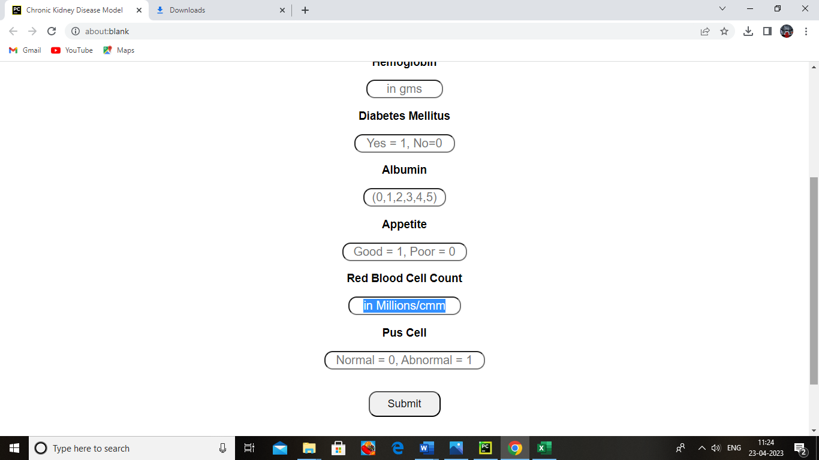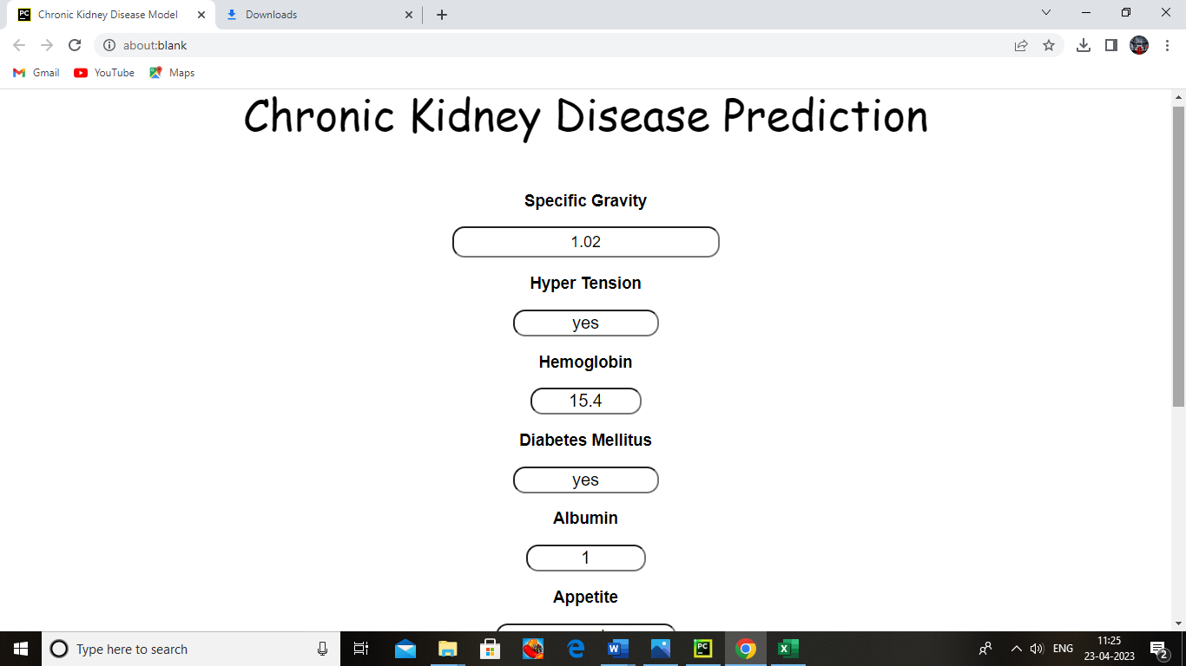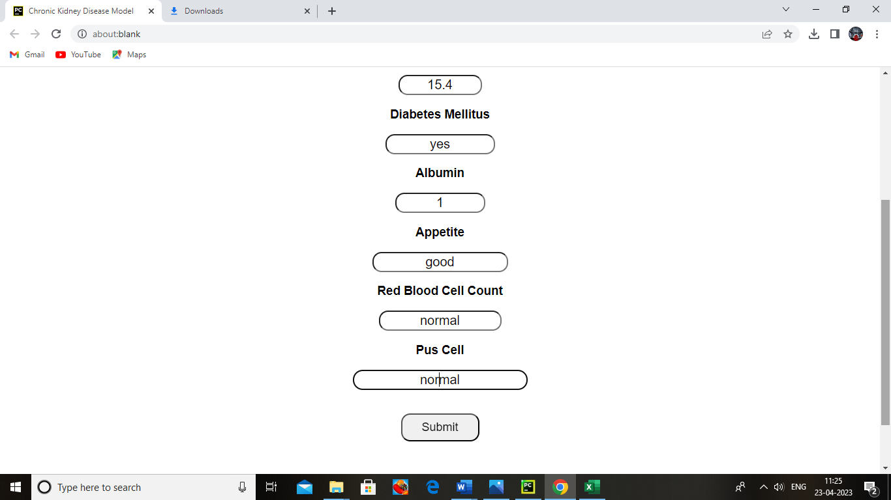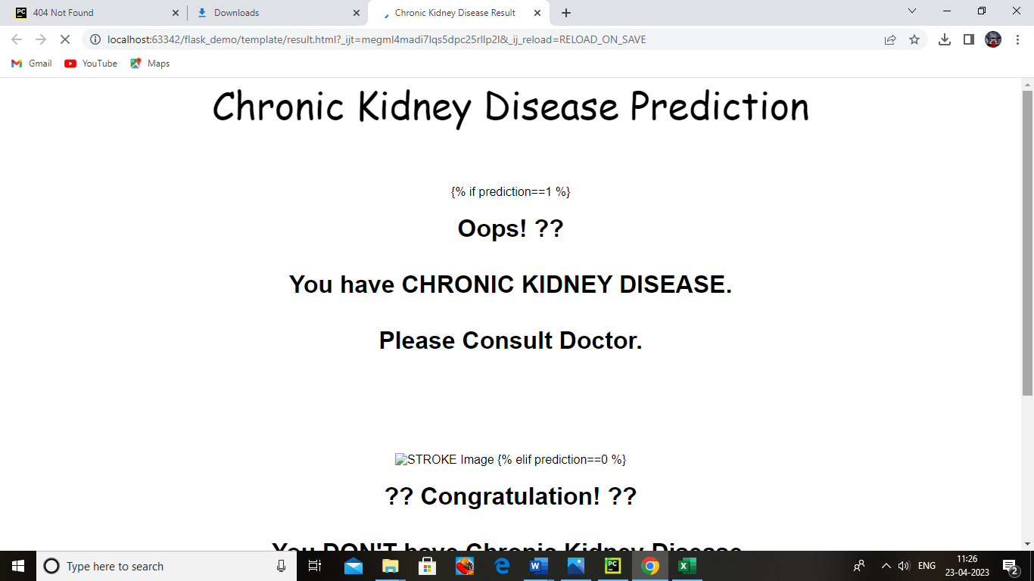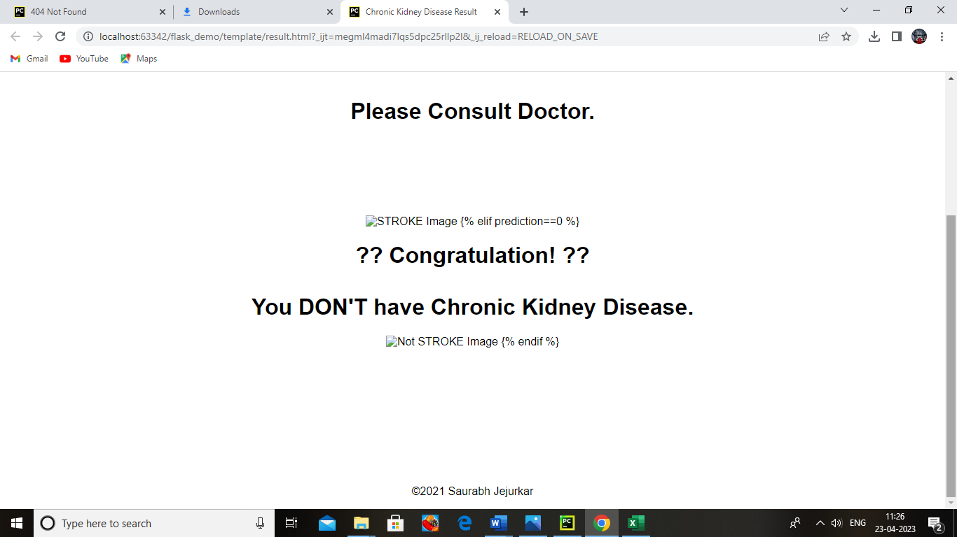

**4.ADVANTAGE & DISADVANTAGES:**

The Proposed System is an mechanism for predicting Chronic Kidney Disease using different classification techniques. CKD ca e classified according to it severeness using machine learning process.

**ADVANTAGES:**

* One of the main advantages of PD over hemodialysis is that the procedure can be carried out in the comfort of the patients’ home.
* For most, all that is required is a washroom with fresh running water, a sterile area of the house for the procedure to take place, and space to store the fluid for dialysis.
* This is also allow patients to travel.
* For elderly patients who may be unable to administer the procedure themselves, assistance may be given by a trained carer or community nurse.
* Additionally, the procedure can even be run while the patient sleeps.

**DISADVANTAGES:**

* Anemia or low red Blood cell count, which can cause fatigue and weakness.
* Extra fluid in the body, which can cause high blood pressure, swelling in the legs, or shortness of breath.
* A weakened immune system, which make it easier to develop infections.

**5.APPLICATIONS:**

* Chronic Kidney disease (CKD) poses a great burden to global public health as current therapies are generally ineffective.
* Early detection and effective therapy are crucial for the future prevention and progression of CKD.
* Nanoparticles (NPs) vary by particle size, shape, charge and the density of targeting ligands and are associated with enhancement of the pharmacokinetic properties, targetablility, or the bioavailability of drugs.

**6. CONCLUSIONS**

In this paper, we employed a web application which can predict CKD , a comparative analysis was performed between KNN yield a better result. From the result obtained it is observed that overall precision, F-measure, recall is 0.971, 0.985, 1 and accuracy is 97.18 percentage respectively.

This shows that KNN yields better result when compared with Naïve Bayes. So medical practitioner can use KNN for prediction of CKD stage predication is done by using GFR, depending on stage diet is recommended by the doctor and they can also upload patient’s treatment details. Patients can access uploaded treatment and recommended diet by the doctor.

The proposed model uses a single algorithm to predict CKD, accuracy of the present work can be enhanced by using hybrid machine leaning algorithms, which gives better accuracy compared with KNN algorithm. Along with this additional feature could be added to enhance our web application in future.

**7.FUTURE SCOPE**

* Dialysis artificially removes waste products and extra fluid from your blood when your kidneys can no longer do this. In hemodialysis, a machine filters waste and excess fluids from your blood.
* In peritoneal dialysis, a thin tube inserted into your abdomen fills your abdominal cavity with a dialysis solution that absorbs waste and excess fluids.
* After a time, the dialysis solution drains from your body, carrying the waste with it.
* A kidney transplant involves surgically placing a healthy kidney from a donor into your body.
* Transplanted kidneys can come from deceased or living donors.

**8.APPENDIX**

**Source code:**



